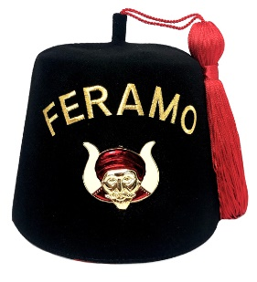

SATURDAY DECEMBER 5th
FERAMO GROTTO INSTALLATION of OFFICERS
For 2021
in
The Commodore Room
Lighthouse Point Yacht and Racquet Club
2701 NE 42nd St Lighthouse Point, Florida 33064

Social hour 6 pm Dinner 7 pm
cash bar available

Menu
Your choice of
12 oz prime rib Chicken Piccata
New England Baked Cod
$ 30.00 pp

Installing Officer Tali Atala, Grand Monarch,
Supreme Council of the Grottoes of North America

Entertainment by Tom Caminiti

RSVP with your menu choice no later than November 10th
to
Incoming Monarch Jim Pappas @ Jpappas34@yahoo.com
or 954 830-2997

Seating is limited due to social distancing

Officers white jacket/prophets & ladies/semi formal or formal

